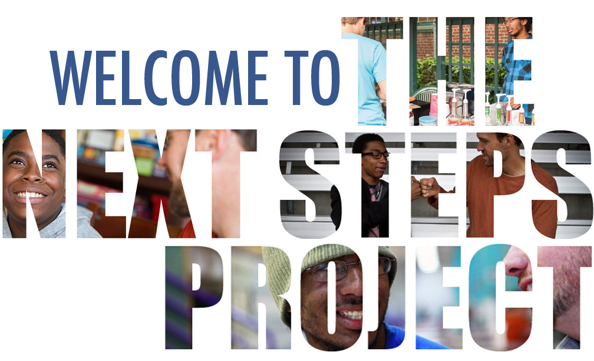POSTSECONDARY COACH HANDBOOK

“Washing one’s hands of the conflict between the powerful and the powerless means to side with the powerful, not to be neutral.”

— p a o l o f r e i r e

“Pick battles big enough to matter, small enough to win.”

— j o n a t h a n k o z o l

TABLE OF CONTENTS
POSTSECONDARY COACH HANDBOOK 1
THE PROJECT 4
WHAT IS FRIENDS OF THE CHILDREN? 4
WHAT IS THE NEXT STEPS PROJECT? 4
YOUR ROLE 5
ESSENTIAL RESPONSIBILITIES & ACTIVITIES: 5
REQUIRED QUALIFICATIONS: 5
VOLUNTEER BENEFITS: 5
AN IMPORTANT NOTE ON THE COACH ROLE… 6
TIME COMMITMENT 7
SCHEDULING 7
LOCATION 7
COMMUNICATION 7
PAPERWORK 8
REPORTING RULES TO TAKE NOTE OF 8
SUPERVISION AND SUPPORT 8
RESOURCES FOR COACHES 9
RECOMMENDED ASSIGNMENTS 10
GAMEPLAN TEMPLATE 10
INDIVIDUAL DEVELOPMENT ACCOUNTS 10
BEGINNING FROM THE BEGINNING 12
POSTSECONDARY OPTIONS 12
ACTIVITY TIPS & IDEAS 12
FREE ONLINE RESOURCES 14
FREE OFFLINE RESOURCES 14
WORKFORCE-BOUND YOUTH 24
RESEARCHING CRITERIA & PREREQUISITES 24
PLANNING FOR SUCCESS & ADVANCEMENT 24
TESTING THE WATERS 26
LOCATING OPPORTUNITIES 26
COLLEGE-BOUND YOUTH (2-YEAR) 28
GAME PLAN 28
PCC SUPPORT FOR FIRST-GENERATION, LOW-INCOME & STUDENTS OF COLOR 29
NEARBY 2-YEAR COLLEGES & TRAINING PROGRAMS 29
FINANCIAL AID 29
COLLEGE-BOUND YOUTH (4-YEAR) 30
PLANNING AHEAD: MAKE & KEEP A CALENDAR 30
OTHER RESOURCES 31
MOTIVATIONAL INTERVIEWING 32
THE 4 PRINCIPLES OF MOTIVATIONAL INTERVIEWING 32
S.M.A.R.T. PLANS 33
HYPERLINKS (FOR HARD COPY HANDBOOK) 34
VOLUNTEER FORMS 34
VOLUNTEER ACKNOWLEDGEMENT FORM 35
CONFIDENTIALITY AGREEMENT 36

THE PROJECT

WHAT IS FRIENDS OF THE CHILDREN?
Friends of the Children was founded in 1993 to provide Portland’s most vulnerable youth with a caring and supportive adult (trained, professional mentors called Friends or simply “mentors”) for the 12½ years from kindergarten through high school graduation.

MISSION: “To provide our most vulnerable children a nurturing and sustained relationship with a professional mentor who teaches positive values and has attainable expectations for each child to become a healthy, productive member of the community.” From http://friendspdx.org/.

WHAT IS THE NEXT STEPS PROJECT?
Next Steps is a collaborative project between Portland Community College and Friends of the Children as part of their Successful Futures initiative “to improve how FOTC helps all youth graduate from high school with the skills to continue their education or gain meaningful employment.”

In other words, the Next Steps Project is a bridge connecting youth to successful futures, as they graduate from Friends of the Children. Systemic inequities and adversities don’t vanish after attaining a high school diploma/GED, and our youth may need support and guidance in determining their paths.

We do this by mobilizing PCC students like you, who are pursuing and achieving a myriad of educational and vocational goals. You skills and expertise for defining and creating a successful future will be invaluable to11th- and 12th-grade youth from Friends of the Children who want help in determining and following their dreams.

“If you want to build a ship, do not drum up the men to gather wood or begin giving orders and assigning tasks. Instead, teach them to long for the vast immensity of the sea.”

«Quand tu veux construire un bateau, ne commence pas par rassembler du bois, couper des planches et distribuer du travail, mais reveille au sein des hommes le desir de la mer grande et large.»

— a n t o i n e d e s a i n t-e x u p é r y

YOUR ROLE

The Postsecondary Coach will be paired with an 11th- or 12th-grade student “mentee” seeking assistance for planning their next steps after high school. The coach and mentee will attend a College/Career Fair together in NE Portland (date TBA) and work together to establish a convenient location & schedule for their sessions, then meet consistently throughout Winter and Spring term. The Coach will use this time to help the mentee discover and asses their educational and career aspirations, determine the necessary action steps and a timeline for achieving those goals, and serve as a guide and “cheerleader” to the mentee. The coach’s job is not to convince youth to go to college, but rather to support them through identifying their individual priorities and goals, and then determining reliable, sustainable paths for achieving them.

ESSENTIAL RESPONSIBILITIES & ACTIVITIES:
- Meet with assigned youth for between 2-6 hours every month, to facilitate activities and conversation that will help youth discover their skills/ strengths, areas of interest, and other relevant life factors.
- Build a productive, attentive, and compassionate relationship with mentee.
- Guide youth through investigating potential/appropriate postsecondary programs (relevant colleges, apprenticeships, internships, vocational schools, etc.) for pursuing that career.
- Help mentee determine and articulate a “game plan” for their postsecondary life, and guide them through the initial action steps to set this plan in motion (e.g. help them submit a FAFSA, write a résumé, etc.).
- Briefly report these activities at http://tinyurl.com/NSPmeeting after each meeting, and communicate with youth’s professional mentor to ensure that your efforts are relevant and supported.

REQUIRED QUALIFICATIONS:
- Must commit to meeting with youth for up to 6 hours every month (for example, weekly 90-minute coaching sessions would be ideal) throughout Winter and Spring term.
- Must attend 2-hour preliminary training.
- Must consent to a criminal background check and agree to abide by conduct/confidentiality guidelines.
- Must be willing and able to work with students from diverse backgrounds.

VOLUNTEER BENEFITS:
- Exclusive access to optional personal/professional development seminars throughout year.
- Experience and references in educational and post-secondary access.
- Possibility of receiving Federal Work-Study (FWS) funds or elective credit through Cooperative Education Internship program.
- Chance to fulfill Community-Based Learning course component (if applicable).
- Opportunity to be a positive force and resource in a young person’s life!

AN IMPORTANT NOTE ON THE COACH ROLE…

Youth in Friends of the Children face significant adversity in their day-to-day lives, much of which you will likely not hear about, but will nonetheless impact their time with you as well as their ideas and hopes for the future. The most important thing a coach can do is to listen with patience, compassion, and an open mind at all times.

That being said, the following four undertakings will likely be invaluable for the youth whom you coach:

- CONNECT THE DOTS.
As the youth is considering various paths and/or careers after high school, encourage them to connect these academic/professional goals to their personal needs and aspirations. For example, do they want to become a physical therapist? Great! Why is that? If it’s because they highly value fitness and have a strong desire to help people, then they’ve picked the perfect path. If they chose this mainly because they heard it pays well, however, it might be worth learning more and exploring other options, before making any definite decisions.

Help the youth clarify how this goal of theirs relates to current and future education and training. If our aspiring physical therapist struggles in high school biology, they are going to need to understand that this career path requires a Doctorate—meaning 8 or possibly more years of college—in order to become a licensed practitioner. Help youth identify the requirements of various paths, but ideally without leaving them overwhelmed or intimidated!

- STRENGTHEN THEIR MINDSET.
Renowned social psychologist Carol Dweck has identified two different ways that people (and adolescents in particular) think about themselves and their abilities, or “self-theories”:
- The entity view holds that intelligence and aptitude are fixed and unchangeable traits. In other words, some people are “born intelligent,” and therefore will always be intelligent, while others simply are not and cannot be intelligent. Entity theorists are “susceptible to learned helplessness”: students who hold this view are likely to avoid activities that stretch or challenge their abilities, for fear of being deemed unintelligent, and are easily discouraged by small failures or setbacks (e.g. “There’s no point trying to pass Algebra because I’m bad at math”). On the other hand…
- The incremental view treats intelligence as fluid, malleable, and—most importantly—attainable through effort and exercise. Students who understand that intelligence is a result of “flexing” and challenging the brain will not only value the process of learning and studying for its practical rewards (becoming smarter) but are also more resilient to failures, since momentary setbacks can be remedied through more practice.
Although the entity view has been scientifically disproven (see, for example, brain plasticity) it is nonetheless mainstream and affects how most students think about themselves and their potential to succeed. Talking to a youth about how intelligence is an earned, not an inherent, characteristic will greatly enhance their resilience, retention, and success in any field.

- BREAK IT DOWN.
Even when students have the “will and the way” (an explicit understanding that intelligence is not inherent but rather cultivated through practice and effort, and a vision of what they want to do next after high school), it can still feel overwhelming—and even impossible—getting from here to there.

Making and following timelines and checklists (e.g. month-by-month to do lists for college admissions) might seem like a basic organizational necessity to you, but it’s a critical skill that many high school students haven’t developed yet. Furthermore,

- WALK THE TALK.
No surprises here… you already know you’re a positive role model… etc.

TIME COMMITMENT
Building a healthy and safe relationship with the youth is essential to providing useful guidance; therefore, coaches should be prepared to attend 2-3 group events during Fall Term (November and December) to meet their youth “match,” and then to meet weekly for 90-minute sessions throughout Winter and Spring term. Coaches should also understand that they may need some time to prepare for each meeting.

SCHEDULING
Once matched, youth and coaches will either meet for their coaching sessions at the Friends of the Children office (44 NE Morris St., Portland OR 97212) or decide on a public meeting place/time that is safe and convenient for both of them.

It’s important to meet consistently: please meet at least twice a month for an hour! NOTE: The youth should have a much autonomy as possible in determining how long/often sessions will be

Discuss and decide scheduling ground rules together: what occasions are appropriate for missing a meeting (e.g. sickness is a valid excuse, attending a party is not a valid excuse)? How much advance notice do will you both need to reschedule (e.g. no rescheduling within 24hrs)? Will there be penalties for “no-shows” without advance notice?

LOCATION
If the youth has returned a guardian release form, it is perfectly OK to hold your meetings in a safe, comfortable public space such as a library, coffee shop, or the youth’s high school. Inform the Next Steps Coordinator once you have determined a space so that it can be approved.
NOTE: Double-check that the youth has safe/reliable transportation to and from your meeting-place.

As indicated in the FOTC Volunteer Manual, meetings may not take place in a private place, such as a home.

Volunteer coaches may not drive or otherwise transport youth. Transportation should occur either through the Friend, or through means approved by the Education Program Leader (we can provide bus passes, for example).

If the youth’s guardian has not signed the consent form, then meetings will take place at FOTC headquarters (44 NE Morris St) under staff supervision (e.g. the Friend, Education Program Leader, or coordinator).

COMMUNICATION
 | If the youth HAS returned a guardian release form… | If the youth has NOT returned a form…
DO | Trade phone/e-mail for program-related communication (scheduling, check-ins, etc.) | Communicate and schedule through the Next Steps Project Coordinator and mentor
DO NOT | Communicate about program-unrelated topics or connect via social media (LinkedIn can be an exception) | Trade any type of contact info or connect via any type of social media
No one, under any circumstances, should trade mailing or home addresses or connect via social media. If a youth requests to be your friend on social media, deny their request and follow up with a conversation about why; it’s perfectly okay to “blame it on the rules” and explain that although you’d like to connect with them online, it simply isn’t legal until they graduate from the program. We must obey privacy laws, but of course we don’t want to hurt anyone’s feelings!

PAPERWORK
The following forms should be completed and returned to the coordinator:
- Confidentiality Agreement (read & sign)
- Volunteer Manual (read)
- Volunteer Acknowledgement page (read & sign)
- Fingerprinting

REPORTING RULES TO TAKE NOTE OF
If you have a grievance to report, inform the coordinator.

If an emergency situation develops while you are volunteering, deal with the situation first and report it afterwards to the coordinator.

If you learn of a situation in which a child is in danger, report the situation to the coordinator as soon as possible.
[If the youth asks you not to tell, explain to them that although they have your full confidence, you cannot sit back and let them get hurt. Please don’t feel like a “snitch”: safety comes first, and all reported information will be treated with utter confidentiality and discretion. It will not be used to hurt the youth. Reporting is required only to keep youth safe, not to break their trust.]

Feel free to discuss any concerns about reporting with the coordinator

SUPERVISION AND SUPPORT
Your sessions will not be directly supervised. The coordinator will check-in with you regularly, however, about how things are going and what you are working on. These check-ins can take place by phone or in-person, whichever is preferable to you.

Please submit a report (http://tinyurl.com/NSPmeeting) after each meeting—taking 30 seconds to do so will be instrumental for helping us evaluate impact!!

The coordinator is there to support you, not only in your work with the youth, but to help connect you with whatever personal or professional development resources would be helpful to you. Please let the coordinator know at any time of any needs/wishes you have or anticipate, or even just to brainstorm and problem-solve together!

RESOURCES FOR COACHES
You may find that the youth you work with has a very different path or plan than for their future you… or that they have none at all! The resources and ideas below are intended to help you when you’re not sure how to proceed.

You are always encouraged to approach the coordinator for more (or different) resources, to brainstorm or troubleshoot, and to request a workshop on any relevant topic.

One of the first things to discuss is how long it will be until the youth obtains their high school diploma or GED (are they in 11th grade on track to graduate next year? Are they in 12th grade but will need to take summer school?).

The resources are divided into sections addressing where the youth is in their planning process: do they have no idea what they want to do with their lives? Turn to “Beginning from the Beginning” on the next page. Have they already been accepted to Concordia University? Start at “College-Bound: 4-Year University”!

RECOMMENDED ASSIGNMENTS
With a few exceptions, all youth with a Next Steps coach will be enrolled for an IDA (Individual Development Account) and should also complete a Game Plan Template by the time they finish their Spring semester.

This should be covered at your Coach Training, but if you missed it or have further questions please refer below.

GAMEPLAN TEMPLATE
Once youth have a general idea of how they want to spend their postsecondary transition (“I want to go to college,” “I want to get a job,” etc.) they can begin to work through the Game Plan Template, which has sections corresponding to their plans.

Not all students need to complete all sections: rather, they should indicate their plans for the future through the “I plan to…” checklist on the first page. They will then complete the sections corresponding to their goals, to ensure that they have thought through some of the logistics and have some sort of action plan.

Youth are welcome to work through the template with you and/or on their own, and also have the option of not filling it out at all—so long as they think through these questions and provide workable, realistic answers in some way. This means they should still read through the template and respond to it, but they can do so in alternate formats (creative writing, painting, music, whatever works for them).

At the end of your time together, the coordinator will conduct an “exit interview” and then hold a little celebration for your youth. This will be an opportunity for them to practice interview skills as well as to showcase the extent of their work and preparation for the future, but should not be very difficult or intimidating as the questions will mostly come from relevant sections of the template.

INDIVIDUAL DEVELOPMENT ACCOUNTS
Friends of the Children has recently started investing its scholarship funds into Individual Development Accounts (IDA). This means that each youth opens a 3:1 savings account—meaning that for every dollar they deposit, they receive 3 more into that account.

The IDA approach is great, because it allows Friends of the Children to quadruple their scholarship funds and put a lot more money toward postsecondary education and training for each youth.

There are a few requirements to maintain IDA eligibility, however, that coaches should be aware of:
- Youth must complete 4 financial literacy workshops before enrolling for their account.
- Youth households must meet the income constraints outlined at http://www.oregonidainitiative.org/apply/
- Youth must deposit at least $25 each month (Friends of the Children does this on their behalf for the first year, so don’t worry about this part. Youth are encouraged to make additional deposits into their account out-of-pocket as possible!). They should check their account balance regularly.
- Youth must write an “Action Plan” that explains how they will spend their IDA funds.
- Youth must not make any withdrawals within the first 6 months of saving.
After meeting these requirements, youth will be able to use their IDA like a combination of scholarship and savings account: they may make withdrawals (minimum $100) to pay for school fees and supplies.
They may not pay for personal expenses with this money, however, and must provide receipts to the IDA provider indicating that each withdrawal was spent on approved items.

Requirements and IDA status may vary by year and by youth, so check with the coordinator for the most recent and most specific information.

For more information on the Oregon IDA Initiative, check them out online at http://www.oregonidainitiative.org/.

BEGINNING FROM THE BEGINNING
If the youth you work with is totally unsure about what they want to do after high school, here are some tips and ideas for how to proceed.

POSTSECONDARY OPTIONS
First thing’s first: introduce the youth to all the different options that they could pursue after high school, and what each of these means.

- Apprenticeships
- Occupational/career school
- Vocational-technical school
- Community college
- 4-year Oregon public college or university
- 4-year Oregon private college or university
- 4-year out-of-state public college or university
- 4-year out-of-state private college or university

Although many long-term plans can be pursued at several of these different kinds of institutions, the expense or time commitment will vary widely—and often in surprising ways. (For example, there’s no reason to discount private 4-year colleges based on the sticker price: if the youth gets a full ride, it could potentially be cheaper than PCC.)

The wealth of options may seem overwhelming, but remind the youth that this is why you’re there: to help them navigate all the possibilities, and find the perfect one for them.

ACTIVITY TIPS & IDEAS

QUESTION

It will obviously be very important to learn the youth’s personal priorities and goals before you start suggesting paths (“What do you think about applying to PCC?” “Maybe we should work on your resumé,” etc.). Although you never want to make a youth feel self-conscious or interrogated, of course, asking a few expansive or open-ended questions could be a productive—and fun!—way to start figuring those out.

Try asking about “big-picture” stuff, for example, and guiding reflection on that. If you ask, “Who do you admire most in the world?” and they say “My big sister,” try and figure out together what it is about Sis that really impresses them. Because she has her own car? Maybe the youth values independence. Because she eats healthy from her garden? Maybe the youth values self-sufficiency. You could even make a list of “Life Models” together: role models with attributes that the youth wants to incorporate into their own future. Then you could start discussing what sort of education or careers will help lead there, or how these elements could best be incorporated into the youth’s future.

Some fun “big-picture questions” are:
- What do you absolutely love in life?
- This doesn’t have to mean a hobby—although activities that make the youth happy/ fulfilled/ enthusiastic make great answers, “family” would also be a very important priority to know about!
- What would you do if there were no limits?
    - Sure its cliché, but there’s no doubt that envisioning this can help reveal further goals. After buying a mansion and sports team, paying off family’s debts/medical bills, and traveling the world… what would they do with their time?
    - It’s fun, and sometimes even inspiring, to think without limits!
    - A variation of this is, “What would you do with your time, if money wasn’t an issue?”
    - This question could involve reflection on how deep wishes could be realized: maybe becoming an NBA star isn’t the most reliable career path, but they could consider applying to staff the YMCA where playing/teaching basketball is part of the job.
- What are your proudest moments?
    - Try to identify why and how the youth succeeded, or what their accomplishment was.
    - Search together for the strengths or skills implied by this.
- What would you stand for, if there was nobody to judge or hurt you?
    - This may sound corny, but if your youth is open to discussing it, this could reveal some of their most deeply held values. Very important to have that in mind, when choosing a career path!!
If the two of you are having a tough time turning these thought experiments into plans or ideas for “next steps,” never fear! Check out the more structured activities below on page 13 under “Free Offline Resources.”

I highly recommend that you also get professional advice/support in this very important endeavor! PCC students can get individualized career assessments done for FREE. Get in touch with the Career Resource Center and try scheduling one for your youth! We’re really lucky to have access to these, because they’re typically very pricy.

LISTEN

It’s important to be encouraging, but don’t feel like you have to shut the youth down when they talk about fears or obstacles. If they say “college is too expensive,” don’t just assure them that “the money is out there” or tell them to take loans. Hear them out: whether the youth is venting about obstacles, or making plans that don’t seem realistic (“I’m just going to win the lottery”), listen to them seriously and make sure you understand what they’re saying and where they’re coming from before cutting them off or offering your input.

In many ways, teenagers have different brain structure—and therefore different ways of approaching the world—even from young adults. The adolescent brain has been a big topic of study for the past couple decades, and there are some very helpful tips for dealing with these differences (i.e., helping teens express themselves and helping them feel heard) in the section titled “Motivational Interviewing.”

TAKE A TEST DRIVE

Questions invariably multiply the more you think about a topic, and discussing this stuff could potentially leave a youth feeling overwhelmed. Try not to let pressure ramp up too fast: If the youth mentions that becoming a dentist could be cool, don’t jump into researching how many years and how many dollars it’ll take to become certified! Think “baby steps” and try some less intimidating, more accessible, and hands-on ways to learn about career paths.

- EXAMPLE: Consider helping them find a dental office to shadow for a couple days, so that they can get a feel for the context. Make sure they feel comfortable doing this; if they’re never shadowed before, give them some pointers! (Here’s a helpful list from San Diego State University.)

- EXAMPLE: You already know that a great way to “get your toes wet” in a career is by volunteering! If the youth is too busy to commit to something regular, maybe there’s a one-day service opportunity (Hands On Greater Portland is an awesome resource) that could help them get a taste of that field without making an intimidating or time-consuming commitment.

FREE ONLINE RESOURCES
- The College Foundation of North Carolina (http://cfnc.org) has compiled extensive online resources for helping students plan for high school, college, or a career. If the youth has internet access at home, they could benefit from the various “Learn About Yourself” tools which profile interests, skills, and values to suggest industries or careers where the youth will be fulfilled and successful.

Although it is intended for North Carolina students, anyone can create an account. The personality profiling tools are probably the most useful for Oregon students, since the college/financial aid resources are oriented towards North Carolina institutions.

- The Oregon Student Access Commission (http://oregonstudentaid.gov/) doesn’t have personality or career profiling tools, but has tons of regionally relevant information for helping Oregon students explore college/university options.

- PCC’s Career Resource Centers have tons of online materials for career exploration.

- CollegeBoard (http://www.collegeboard.org/) has tools for comparing colleges and universities to one another, as well as for helping the youth compare their performance in school and on standardized tests to the students typically admitted to various colleges and universities. This can be especially helpful for youth with average grades and test scores, who aren’t sure that they’re prepared for college.

- Cappex (http://www.cappex.com/) is probably most useful for students who know they’re college-bound and want more in-depth information about the “personality” of various institutions… but exploring this site could help youth feel more familiar with the college context, and create “buy-in” so that they feel invested to work on attaining admission and financial aid.

FREE OFFLINE RESOURCES
Not all youth have access to the internet at home, and it’s hard to get to know someone when you spend all your time together staring at a computer screen. Here are a couple free resources that I’ve found for personality profiling and exploring career clusters.

THE KEIRSEY TEMPERAMENT SORTER
(SEE PAGES 12-17 FOR WORKSHEET)

This is admittedly not the most colorful activity: the questionnaire, followed by a scoring sheet, will reveal your Myers-Briggs personality type. MB type is NOT a “last-word” or comprehensive descriptor, but it can be useful to get people thinking about their personal/cognitive proclivities (e.g. “It’s very true that I’m introverted and a rational thinker; I think I’d prefer an analytical job, maybe in statistics, where I can work alone. Maybe I should get out of customer service.”

After completing the survey (70 this-or-that questions) and tallying up their answers for results (see “Directions for Scoring), they’ll end up with one of 16 acronyms that represents their “type”. There’s quite a bit of information out there on decoding/interpreting these: I recommmend the Myers-Briggs website (http://www.myersbriggs.org/my-mbti-personality-type/mbti-basics/the-16-mbti-types.asp) for starters. If you want to find interpretive materials offline, check the library nearest you or ask the coordinator.

If the student feels that this personality profile describes them well, it can be a “key” or starting-point for them to start thinking about their intrinsic skills, values, and interests. Would they prefer a job that is analytic? Social? Artistic? What kind of work environment might make them feel most comfortable and fulfilled? Help them work through questions like these that could spark insights about the right career path(s).

UNPACKING GOOD EXPRIENCES
(SEE PAGES 18-19 FOR WORKSHEET)

This could make a good “homework assignment” to get youth thinking about this stuff in between your meetings. It’s a worksheet activity to help youth start to “unpack” their past experiences of success or fulfillment, and to use them as a clue for revealing their personal skills, strengths, and interests.

Ideally, this would help them identify paths that correspond to those traits, which will complement their innate/learned aptitudes leading to further success and fulfillment (e.g., “my good experiences all involved coordination, love for design, creativity, human relations, and showmanship. Maybe I should go to college and study painting and education, so I can become an art teacher.”)

The directions are straightforward: start with the “good experiences summary.” In #1a, write a good experience you had in which you held an active/central role: hearing a favorite musician perform is a passive experience, whereas putting on your own house show is an active one.

Now think of as many more good experiences as possible, and fill in #1b—1t.

Follow directions #2 and 3 (on the page) to complete this activity and get your “skill clusters.”

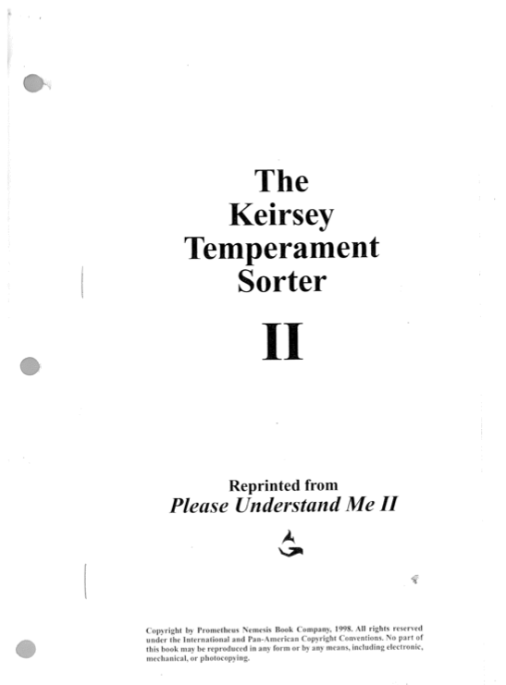

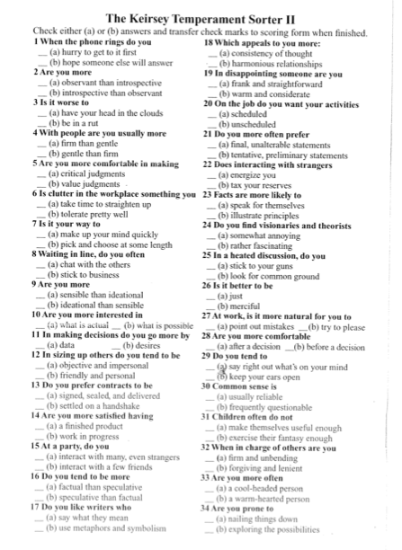
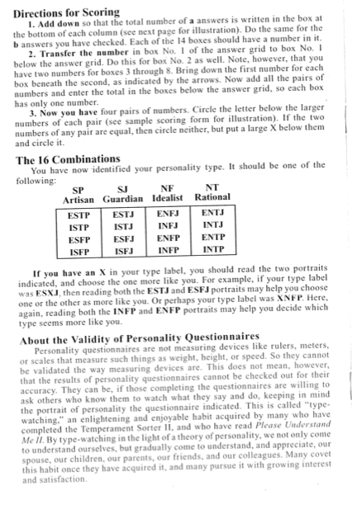
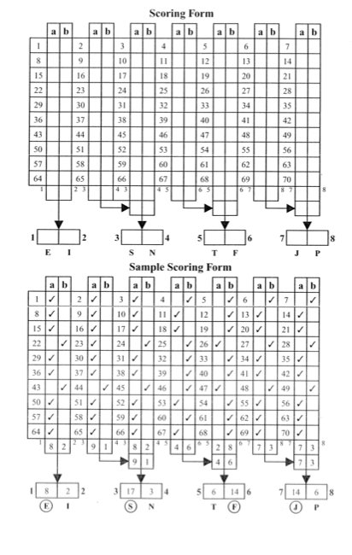

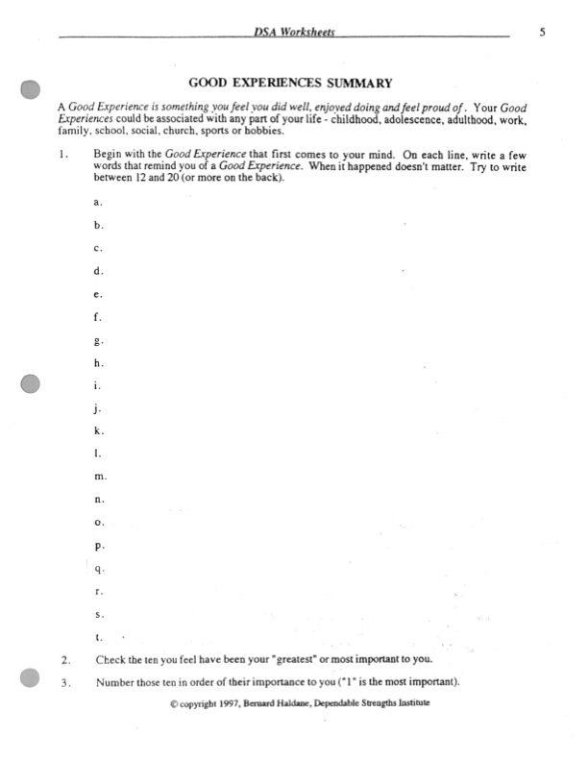

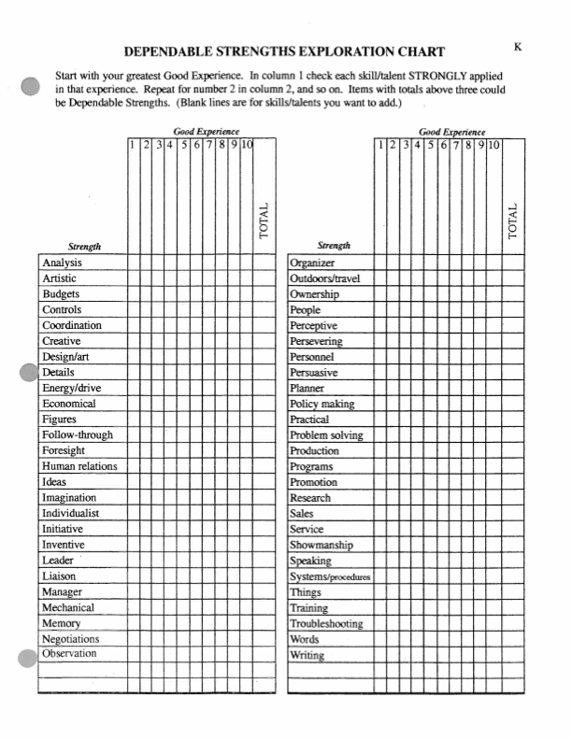

WORKFORCE-BOUND YOUTH
What if the youth you work with already knows what job they want to enter after high school? Your role then will be not only to support their entry to that position, but to help them understand the implications for that choice: Are there opportunities for advancement in that field? Does that job have sufficient benefits and pay to cover their costs of living? Will that job enable them to achieve personal goals like starting and supporting a family?

Furthermore, you could really be helpful to a youth by helping ensure success within their career. Sharing your skills concerning resumés, cover letters, and good interview strategies can help a high school graduate obtain their job—but connecting them with resources and mentorship in that field can help their success and retention within it.

RESEARCHING CRITERIA & PREREQUISITES
If the youth has already determined what career they want to enter, you should both spend time figuring out what they will need to gain employment:
- What are the prerequisite skills/skill sets? Does the youth have these? How can they [further] develop them?
- What kind of education will be necessary? What diplomas or certifications are required, where can they be obtained, how much will they cost, and how long will they take? Is this realistic and attainable?
- Will they need work experience before entering this field as a full-time employee? Is their resumé currently adequate for employment?
- Is the entry-level salary sufficient to support the youth? Have they made a feasible budget? Will they be able to afford the necessities for success in their job (transportation, appropriate clothing, etc.)?
There are many such questions to consider, depending on the job chosen, that may not have occurred to the youth and/or that the youth may not be able to research.

Try scheduling appointment with one of PCC’s Career Resource Center Coordinators, and attending it together with the youth: this could be an opportunity for them to practice face-to-face interaction/informational interviewing with professionals, as well as to learn about their field of choice.

If the youth isn’t comfortable with, or wouldn’t benefit from, an appointment—try simply dropping by a Career Resource Center office! There’s tons of helpful stuff over there for helping the transition into many fields, such as:
- Career-based seminars and workshops throughout the year,
- Lunch with professionals (another opportunity to practice informational interviewing),
- Free personality/career assessments to ensure compatibility,
- Research materials, such as compilations of career websites and tips on informational interviewing, information about current career trends, and a booklist + library of essential information for various jobs!
Even if the youth won’t be attending PCC, you can usually “spread the wealth” by leveraging your own student status to connect them with these resources.

PLANNING FOR SUCCESS & ADVANCEMENT
Once the youth has decided to be committed to that field, it’s time to start making a plan for success. Although this should definitely involve a practicum component (see “Testing the Waters” on p. 25), that work will largely be the youth’s responsibility; where you can be especially helpful is in helping them create a “game plan” or “roadmap for success.”
The intention here is to co-create something that will support the youth even after your time together ends. In order to prosper in their career and achieve financial stability, they’ll need to have thought through potential obstacles and made plans for dealing with both them, and with the likely resulting stress.

There are all kinds of different templates available online for making a “career action plan” (see http://hrweb.berkeley.edu/files/attachments/Career-Development-Action-Plan.pdf, for example. None of them are particularly innovative, but they have some good structure and suggestions that could be useful activities. Try asking the youth to google “career action plan” or “career advancement roadmap” (etc.) together, and have them make their own worksheet by selecting all the most relevant elements from each hit.

Another option is to ditch templates entirely: take. a more tactile approach by creating a collage or painting of yourselves in 10years, and then discuss how to get there. The main goal is for the youth to know what tools/skills they’ll need to have, and what moves they’ll need to make, to ensure their success and security.

One of the most important things to do together is writing a calendar or timeline that the youth can rely on even after your time together.

For example, a 12th-grader interested in becoming an Emergency Medical Responder could write a plan like this:

December 2013
- Pass all Fall Semester high school classes
- Get more shifts during Winter Break & save all earnings for EMT certification tuition next year
January 2014
- Enroll for an IDA; submit my FAFSA; apply to OSAC; start researching EMT-specific scholarship opportunities
- Get First-Aid/CPR/AED certified
- Contact Portland Fire Department for volunteer or internship opportunities
February 2014
- Check with HS Academic Counselor that I’m on track to graduate
- Start volunteering weekly for 1 hour with Portland Fire Department
- Finish FAFSA & apply to EMT-specific scholarship opportunities
March 2014
- Start researching summer employment opportunities that yield relevant experience or contacts (e.g. emergency hotline operator? Outdoor camp nurse position? Lifeguard at local community or college pool)
- Continue volunteering with Portland Fire Department
April 2014
- Check again with HS counselor that I am on track to graduate
- Find an experienced EMT @ Portland Fire Department & ask to do informational interview; job-shadow them or ask for mentorship/tips
May 2014
- Graduate HS, yay!!!
- Apply to relevant summer job for gaining EMT experience
June 2014
- Start summer job
- Update LinkedIn
July 2014
- Review FAFSA results & other scholarship income; budget for EMT certification. Make sure all tuition is covered, and also costs of living
- Register for full-time EMT course load
- Find a part-time job with flexible hours as temporary “backup” so I can make a living in case I don’t find EMT work right away
August 2014-June 2015
- Get intermediate EMT certificate
- Continue working part-time and volunteering at Portland Fire Department (switch roles to intern if possible) + networking
January 2015
- Apply for EMT position with Portland Fire Department.
- Enroll part-time in EMT Paramedic certification program and complete courses as new work schedule allows
- Start working on FAFSA for new year
Etc.

An important element of this will be considering the future of the field. Websites like http://oregoncis.uoregon.edu/Portal.aspx predict the job market and economics surrounding various occupations. Long-term plans should always incorporate this kind of research: it’s really important to know if salaries are if unemployment is expected to spike in that field 5 years from now!

TESTING THE WATERS
The next important step in preparing for a career will be trying it out. There are several ways to get some experience in the field without having to make a big, intimidating, high-stakes commitment: volunteering, job-shadowing, and internships are some common options.

Check the “try stuff out” sub-section under “Activity Tips & Ideas” on page 12 for more information on practicum options in Portland.

Or, if the youth has internet access, encourage them to explore Mac’s List (http://www.macslist.org/), a Portland-based employment website which posts openings state-wide (and often out-of-state in the wider Pacific Northwest) for jobs, internships, and volunteer positions. You can search by industry, by keywords, by city, and results always include contacts/instructions to apply.

Even if a youth doesn’t find employment this way, you could always have them print out desirable positions and practice writing cover letters, etc.

LOCATING OPPORTUNITIES
ONLINE The entire hiring process, from job postings to applying, are shifting more and more to the web. If the youth doesn’t have internet access at home, see what you can do to get them plugged in elsewhere: maybe their high school, or a local public library, has computer labs where they can work job searches. PCs at FOTC are prioritized to youth doing job-related work!

Mac’s List (mentioned above under “Testing the Waters”) is a good place to start the job hunt. I also recommend visiting the Oregonian’s online classifieds, at http://www.oregonlive.com/jobs/.

Another important online stop is LinkedIn (http://www.linkedin.com/): having a clean and complete profile—even if the youth doesn’t have much work experience—can boost their options for finding employment.
- It’s becoming standard practice for employers to Google applicants. Youth want the first hit on any search for their name to be a positive and professional presentation of self!
- Sometimes bilingual/multilingual folks get job offers through LinkedIn just by indicating which languages they speak/write fluently! It really happens, and translating jobs are often cushy, flexible, and well paid—not to mention they yield professional references and can be the stepping stone to a more steady job
- LinkedIn can be a less intimidating context for networking. Youth who are shy or inexperienced about “schmoozing” with professionals can practice online, where stereotype threat and the pressure of being on-the-spot are less poignant.

OFFLINE For youth who can’t consistently get online, try going old school and searching through Classifieds together in various newspapers. If the youth is planning on moving out of the city/state, see if you can get your hands on local newspapers from there! Also research where the most/best openings in their field are: it could be smart to see what the job market is like in other places.

I highly recommend getting in touch with instructors or students at PCC who are in the field your youth wishes to enter; anywhere from 40-60% of job openings go to someone who didn’t respond to a posting. In other words, “it’s not what you know… it’s who you know.”

You can be a critical resource for connecting youth to folks who can jumpstart their career!!! While you’re not expected to network for them, leveraging your status as a PCC student on behalf of a youth to put them in touch with experienced players in their desired field has great “gamechanging” potential.

COLLEGE-BOUND YOUTH (2-YEAR)
Nobody knows the “tips of the trade” for 2-year colleges better than you! I highly recommend exploring the “Possibilities Playbook,” included in your training swag bag, but here are some additional considerations for supporting youth who want to enroll in a 2-year college.

GAME PLAN
The first order of business for a community college-bound student is to determine what they’re going for. If your youth finishes high school and starts at a community college without a clear direction and game plan, it’s going to be very difficult for them to succeed & move on; furthermore, they’ll be vulnerable to potentially “wasting” time and money early on, in courses that might not be transferable or relevant to their ultimate pursuits.

In a nutshell, we don’t just want to help youth get in to 2-year/community colleges: we want to help them get out, too!

GAME PLAN: ASSOCIATE’S DEGREE OR CERTIFICATE If the youth is planning to enroll and achieve a 2-year degree (like Associate’s of Arts or Associate’s of Science) or certification (like the intermediate EMT training course in the example from page 24), they should be able to find a list of “Comprehensive Requirements” detailing every class, and every credit, they will need to take to obtain that degree. This can be obtained either departmentally or through the registrar (Registration/Admissions Office).

GAME PLAN: TRANSFER If the youth is starting their education at a 2-year institution and then transferring to a 4-year university, you should put them through pretty much the same process that students applying directly to a 4-year school go through, sans the applications.

Youth should still research and “shop around” for universities, considering their personal needs (“Which schools are driving distance from my family and offer health care?”), academic needs (“Which schools have significant support for students with learning disabilities?”), and career needs (“Which schools have a strong and reputable pre-med program?”).

Even though the youth has a few academic terms to figure out which 4-year they’ll attend & work on their application, it’s important to have a firm idea of where they’re considering even before registering for classes. The requirements for transfer students are often rigorous and vary widely, so if the youth can realize early that they want to attend a public, Oregon school—even if they’re not sure yet which one—they can start fulfilling the transfer requirements right away and think strategically during their time in 2-year college.

PASS THE TORCH: As a PCC student, you probably know that there are a host of programs and resource centers available to students, many of which are specifically designed to help students overcome common barriers to higher education (e.g. the ROOTS program, which specifically reaches out to low-income students who are the first in their family to attend college).

One of the most valuable things you can do for a student to ease their transition into higher education, is to connect them with these resources before your time together ends.

If you can find the time to create a personal connection, rather than just telling the youth about these support programs, it will be invaluable. For example, a high school senior who is Latina and planning to attend PCC Rock Creek could really benefit from meeting in-person with the Oregon Leadership Institute (OLI) coordinator.

PCC SUPPORT FOR FIRST-GENERATION, LOW-INCOME & STUDENTS OF COLOR
This google document (https://docs.google.com/document/d/14uIOhuVjXOflqr9BNaQPk5t7Fy18PiDwYzmI4DV3RDY/edit?usp=sharing) was compiled in June 2014, to list all the programs and resources offered by PCC to local high schoolers and incoming/current PCC students facing adversity. All of these programs are designed to boost retention and support diploma/degree attainment, though their target audiences vary*. If the youth you coach is considering PCC and/or alternative high schools, please check this list to see if any of these resources would be helpful to them.

Please also suggest additions or revisions to this list as available PCC support programs change and/or expand!

*For example, ROOTS is open to all low-income and/or first-generation students, whereas Portland Bridges to Baccalaureate primarily recruits medical students of color, with the intention of challenging racism in that field.

NEARBY 2-YEAR COLLEGES & TRAINING PROGRAMS
PCC is, of course, a huge and incredible institution of higher ed. If this is not the right option for your youth, however, they can also consider:
- Clark College in Vancouver, Washington (which offers an Oregon Border Waiver, allowing “students from Multnomah, Washington, Columbia, Clatsop, Hood River counties among others to take classes at Clark at Washington State tuition rates.” Sweet!),
- Mt. Hood Community College in Gresham,
- Various for-profit institutions and training programs.
Please note that the last option, while viable and potentially the best path for some youth, should be rigorously researched and investigated. For-profit educational institutions are notorious for stretching or bending the truth in advertising; for example, Corinthian Colleges was recently sued for its predatory practices and misleading claims about job placement rates. Help the youth schedule interviews with college representatives and ask hard questions; it’s not always easy for a teenager to advocate for themselves in the face of slick recruiters and big institutions!

FINANCIAL AID
Community Colleges are some of the most affordable higher education options out there, and helping a youth make the most of financial aid can often enable them to attend for free!!

It’s therefore very important for 2-year college-bound youth’s family to file taxes so they can fill out the FAFSA and apply to OSAC.

For more information and guidance on the FAFSA, see the new Finanial Aid Toolkit online (http://financialaidtoolkit.ed.gov/tk/).

COLLEGE-BOUND YOUTH (4-YEAR)
ASPIRE (Access to Student assistance Programs In Reach of Everyone) Oregon has been matching middle and high school students up with volunteer mentors who help them develop an education plan beyond high school… much like the Next Steps Project does!

Unlike Next Steps, however, ASPIRE has been doing this since 1998, so we’re going to defer to their tried-and-true approach, rather than trying to reinvent the wheel. As a pre-ASPIRE site, FOTC has access to their training and resources!

Please refer to the ASPIRE handbook provided at the training if your youth is planning to attend or transfer to a 4-year university. If you did not receive an e-copy or hard copy of the ASPIRE handbook, contact the coordinator.

PLANNING AHEAD: MAKE & KEEP A CALENDAR
ASPIRE’s handbook includes an excellent calendar for postsecondary planning, which includes monthly deadlines and actions organized by whether the student is a junior or senior.

This is a great starting point and guide for you in your work, but it’s also crucial to share this with your youth!! You can probably remember how much stuff you had going on in high school, and a lot of these kids are trying to balance a job, caring for siblings, and other responsibilities on top of all that… this can make anticipating and meeting deadlines on your own feel almost impossible, especially when the college application process seems like a total mystery!

One of the best, and most empowering, remedies for that is to BREAK IT DOWN. Take this ASPIRE calendar as a starting point, and find “baby steps” that the youth can take every month to attain these goals. Need to fill out the FAFSA? Write down every single thing that needs to happen for completion, starting with “filing taxes.” Then write down everyone who can support the youth through each of these steps, and when. Include this on the calendar, with goal dates and reminders!

OTHER RESOURCES
The AmeriCorps VISTA will be compiling and distributing resources, ideas, new/relevant research, and supplementary materials as much as possible throughout the course of your service.

In order to find the best possible resources, though, she will need your input and feedback on what would be helpful!

The VISTA also wants to bring in professional expertise for workshops, lectures and/or trainings on topics that would be of use to you. Taking a moment to communicate about any challenges as they come up is one way for the VISTA to know what she should focus these optional development sessions on!

Alternatively, you can go to the VISTA for anything that would be helpful for you—even little stuff like “How can I make next week’s meeting more fun?”

Collaborating with one another is great, too! Two heads is better than one, and all 12 of you together would be a force to reckon with A lot of the students you’ll be working with know one another, so if you and another coach are working with best friends… try teaming up! Do a college visit together, or coordinate a “double-date” session to inject some fun and peer interaction.

Above all, the most helpful and empowering thing you can do to help youth plan for and navigate their postsecondary transition is to BREAK IT DOWN. Whatever their goals are, parsing out the individual steps or “sub-actions” and support network to make it happen will not only show the youth that they’re not alone: it will help them see that their dreams are achievable, one day at a time.

MOTIVATIONAL INTERVIEWING
Motivational interviewing (MI) is a counseling approach developed by clinical psychologists William R Miller and Stephen Rollnick. Although intended to motivate/elicit positive behavioral change (i.e. to help people overcome and recover from alcoholism), which is obviously not relevant to the Coach role, MI has helpful tips and techniques for engaging intrinsic motivation to meet goals. This could be very helpful to youth who are struggling with consistency—having difficulty pursuing long-term goals in their day-to-day activities.

MI’s three-pointed strategy of strategically asking open-ended questions (EVOCATION), listening attentively and reflectively (AUTONOMY), and providing affirmation (COLLABORATION) can be used individually or collectively to:
- Develop a safe relationship in which the youth is (and feels) heard, taken seriously, and supported;
- Guide a youth through discoursing about + determining their values, goals, and long term plans;
- Encourage/“cheerlead” a youth as they pursue those plans and encounter difficulties.

There are a few very relevant tenets that MI upholds as a guide to interacting with people pursuing change:

- Motivation comes from the youth, and cannot be imposed.
- The youth is an expert in their own experience, and is ultimately responsible for articulating and resolving their own ambivalences.
- Persuasion is not an effective method for resolving ambivalence.
- Listen more than you speak (sometimes called the “2:1 rule”—we have two ears and one mouth so we can listen twice as much as we speak).
- The coach is directive, eliciting key information from the youth to help them find solutions on their own to conflicts that they face, and to resolve ambivalences that they feel.
- Preparedness for change is not a trait of the youth, but a fluctuating result of interacting with environments and people. [You, the coach, can be a significant part of this landscape of interactions.]
- The coach is a partner/companion, not an instructor or taskmaster.

Again: our role is not to facilitate behavioral change, but rather to facilitate the youth’s identification, pursuit, and achievement of career and life goals. However, the strategies outlined by Drs. Melanie A. Gold and Patricia K. Kokotailo in this paper (“Motivational Interviewing Strategies to Facilitate Adolescent Behavior Change,” 2007) can nonetheless be a helpful guideline for encouraging and bolstering youth autonomy. I’ve copied some highlights below, and recommend referring to the paper in full.

THE 4 PRINCIPLES OF MOTIVATIONAL INTERVIEWING
- Facilitate behavior by expressing empathy’

“Accepting patient beliefs and behaviors… is more effective than applying pressure through persuasion. Direct persuasion (“finger-wagging”) usually elicits resistance, especially among adolescents… Create a nonjudgemental environment that allows the adolescent to talk openly about behaviors and beliefs. Practice reflective listening to communicate understanding. [If the youth] describes a behavior with a negative impact, temporarily compartmentalize and hold off on voicing your concerns. Encourage an alliance by resisting the urge to give advice until it is requested or at least ask for the adolescent’s permission before offering an alternative point of view.”

- Develop discrepancy

“Develop discrepancy by recognizing inconsistencies between current status and important goals, or between current behavior and important values. Adolescents who are aware of these inconsistencies will usually attempt to make changes…”

- Roll with resistance

“Resistance usually occurs when the [youth] feels pushed to do something he or she is not yet ready to do. Signs of resistance include arguing, interrupting, denying there is a problem, ignoring the [coach], missing appointments, presenting too late for an appointment, or failing to complete requested tasks. In MI, arguing and persuasion in the face of ambivalence are deemed
counterproductive... [because they] can be expected to elicit a defensive response and increase resistance. If you see signs of resistance, shift to a new strategy.

- Support self-efficacy in each encounter with youth.

[Positive action] is most likely to occur when a problem is recognized and the patient believes in his or her ability to do something about it [i.e. “My family doesn’t have money for me to study nursing, but I can apply for federal and private scholarships]. Communicating optimism about the motivated patient’s ability to succeed at a desired change is a powerful facilitator… Support self-efficacy by expressing your optimism. Point out, with permission, that change is not an all-or-nothing venture. Describe the [youth]’s past successes and failures as learning opportunities. Help the adolescent identify a rage of effective alternatives [options] for achieving his or her goals.”

S.M.A.R.T. PLANS
As obnoxious/cliché as acronyms can be, this one might be useful for guiding the youth’s—or even your own—planning process.

SMART plans are:

S—Specific
M—Measurable
A—Achievable
R—Realistic
T—Time-framed

A SMART plan should answer the following questions:

- What is my plan?
- What small steps can I take every day toward my goal?
- Why is this important to me?
- What things could get in the way to my plan, and what are solutions to these barriers?
- Who can help me, and how?

HYPERLINKS (FOR HARD COPY HANDBOOK)
All the hyperlinks in this handbook will work in the electronic PDF copy. For hard-copy users, however, they are listed here by Page #: “text of hyperlink” <url>.

11: “career assessments” http://www.pcc.edu/resources/careers/resource-centers/assessments.html

12: “Here’s a helpful list” http://www.sdstate.edu/gs/students/advising/upload/Job-Shadowing-Tips.pdf

12: “Hands On Greater Portland” http://www.handsonportland.org/

12: “College Foundation of North Carolina” https://www.cfnc.org/index.jsp

13: “Myers-Briggs Personality Type” http://en.wikipedia.org/wiki/Myers-Briggs_Type_Indicator

24: “personality/career assessments” http://www.pcc.edu/resources/careers/resource-centers/assessments.html

24: “research materials” http://www.pcc.edu/resources/careers/resource-centers/career-exploration.html

29: “public, Oregon school” http://www.ous.edu/

29: “transfer requirements” http://www.ous.edu/stucoun/transfer/admission

29: “think strategically” http://www.ous.edu/stucoun/transfer/planning

29: “the ROOTS program” http://www.pcc.edu/resources/roots/

29: “Oregon Leadership Institute” http://www.pcc.edu/resources/culture/rock-creek/oregon-leadership/

29: “Clark College” http://www.clark.edu/

30: “Corinthian Colleges was recently sued” http://america.aljazeera.com/articles/2013/10/11/california-attorneygeneralfilessuitagainstforprofitcollege.html

30: “OSAC” http://oregonstudentaid.gov/

31: “ASPIRE” http://oregonstudentaid.gov/aspire-about.aspx

31: “1998” http://oregonstudentaid.gov/aspire-about.aspx

34: “this paper” http://www.dhs.wisconsin.gov/health/mch/PDF/AdolescentMotivationInterviewing.pdf

VOLUNTEER FORMS
These are the 2 forms that need to be completed and returned the FOTC before you can begin volunteering.

VOLUNTEER ACKNOWLEDGEMENT FORM
This is to acknowledge that I have received a copy of the Friends of the Children—Portland volunteer manual and understand that it sets forth the terms and conditions of my volunteer activities as well as my duties, responsibilities, and obligations as a volunteer for Friends of the Children – Portland. The volunteer manual applies to all volunteers. This volunteer manual is not a contract, nor is it intended to cover every policy, practice, or situation that may be encountered. Friends of the Children – Portland reserves the right to make changes at any time to any part of this manual, including any policy, procedure, practice, or expectation described herein.

I understand and agree that it is my responsibility to read and familiarize myself with the provisions of the volunteer manual and to abide by the policies and practices set forth in it at all times.

Name (please print)

Signature Date

CONFIDENTIALITY AGREEMENT

Each Volunteer may be privy to confidential information about the Chapters, program children and their families, Friends of the Children staff, process, issues, and the organization in general. As an organization, Friends of the Children does everything possible to protect the confidentiality of each Program child, family, staff member and volunteer. However, it is the responsibility of each person who is a part of the organization, paid or volunteer, to respect these confidences.

Much of the information we deal with at Friends of the Children is sensitive in nature. We treat this information with care and respect, and it is important that this information is held in confidence. Confidential information includes, but is not limited to, the following:

Children’s Names, Folders and Experiences Employee Names and Records Financial Information
Family Information and Experiences Child Assessments Donor Information
Management Plans Evaluation Instruments Contracts
Work processes and issues Information about other Chapters

In order to protect the confidentiality of such information, please take care when discarding any information/documentation outlined above by shredding/destroying the confidential material. Anyone who violates the confidentiality required by Friends of the Children will be asked to resign as a volunteer.

I understand that the work, the children and Friends with whom I volunteer entrust the program with highly confidential information. With this in mind, I will protect their privacy and confidences to the best of my ability except in an effort to protect the children from harm. I will not discuss them or their family matters, or any work processes or procedures, with persons or agencies outside Friends of the Children. If asked to share stories about Friends of the Children youth, I will seek advice from the Program Director or the Executive Director.

If I observe information from other chapters in the FOTC network, I will not discuss the content, nature or quality of the information with any other chapter including the local Portland chapter.

I fully understand the importance of protecting the confidentiality of Friends of the Children. I also understand the importance of protecting Friends of the Children youth from harm.

By signing this agreement, I agree to keep the confidentiality entrusted to me by the children, their Friends, Friends of the Children staff, and the organization in general.

__________________________________________ ____________________
Name Date

For more detail on this, check http://www.parentingscience.com/theory-of-intelligence.html
http://www.learning-theories.com/self-theories-dweck.html
http://www.psychologicalscience.org/journals/cd/12_1/Kolb.cfm
http://www.nytimes.com/2014/05/18/magazine/who-gets-to-graduate.html?_r=0
http://www.ncbi.nlm.nih.gov/pubmed/17328703

